

**Introduction to Computer Vision**

**Coursework**

**Submission 1**

**Your name Nicholas Franklin**

**Student number 150402149**

**Question 1(a):**

**Rotated images:**

θ = -50 deg

θ = 60 deg

θ = 30 deg

θ = 120 deg

**Skewed images:**

θ = 10 deg

θ = 40 deg

θ = 60 deg

**Your comments:**

**At first, I skew very much in the wrong dimentio. Resulting in a matrix that implied I had skew. Turns out this was actually that I was multiply the matrix in the wrong order. Resulting in a y skew instead of an x skew.**

**I was skewing with the bottom left pixel at 1,1 not 0,0**

**In addition, because matlab treats the top left as the origin. The skew matrix is the symtrical matrix of the standard bottom left origin based matrix.**

**New problem. When I use a negative value for the angel it errors out. As the position of some points is below 0.**

**Solved by sizing the image based on the difference in location of the max and min points in the image. Then shifting the image into positive space to display the image.**

**Because matlab matrix origin is in the top left then to get then to get a right shifting skew from the bottom left we need to**

**I had no problems with rotation until I got to gap filling. The main problem I had was differentiating between a hole and a piece of the extension to the image so the rotation is not cut off.**

**I made an array of -1’s with dimension large enough to fit the whole output image. Then I output the new pixels into their required positions. Next I loop thought each pixel in the image ignoring any pixels where they had 1 or less non -1 in there 4-neightborhood. This results in my images being very slightly enlarged on the edges.**

**My hole filling is failing to fill anything with white.**

**Learnt how cell arrays worked so that I could find overlayed pixels.**

**Question 1(b):**

θ2=50 and θ1=20 clockwise

θ1=20 clockwise and θ2=50

**Your comments:**

**Question 2(a)**:

**Designed kernel:**

**A box blur**

Averaged image

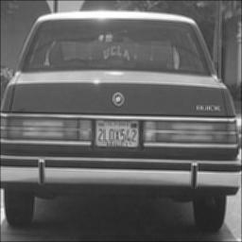

Original image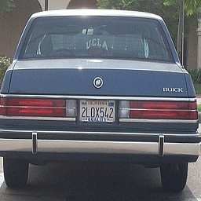

**Your comments:**

**Question 2(b):**

**Filtered image with kernel A**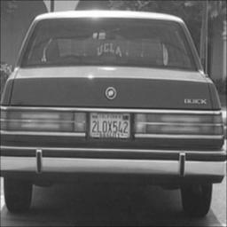

**Filtered image with kernel B**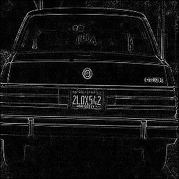

**Your comments:**

**Question 2(c):**

A followed by A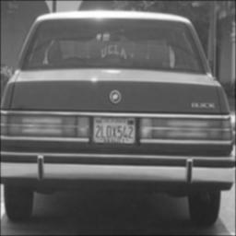

**A followed by B**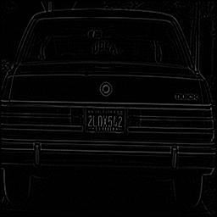

**B followed by A:**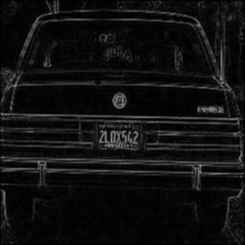

**Your comments:**

**Question 2(d):**

**Extended kernels of A and B (5x5):**

**Results obtained by applying 5x5 kernel:**

**B followed by A**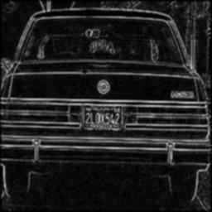

**A followed by B**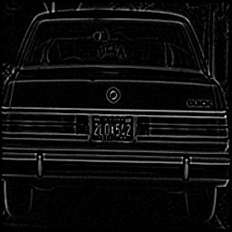

**A followed by A**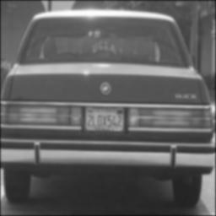

**Extended kernels of A and B (7x7):**

**Results obtained by applying 7x7 kernel:**

**A followed by A**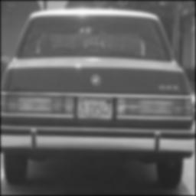

**B followed by A**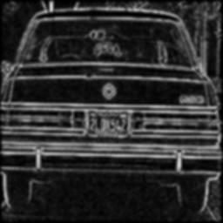

**A followed by B**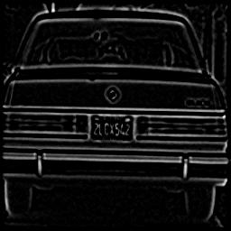

**Your comments:**

I identified kernel A as a gaussian blur so my 5x5 kernel is what I remember a 5x5 gaussian blur to be.

**Question 3(a):**

**Two non-consecutive frames: Frame 100 , 200**

Image 1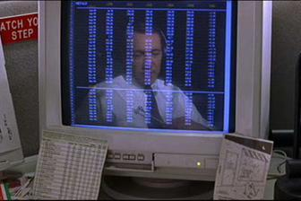

Image 2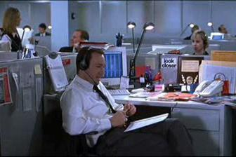

**Corresponding colour histograms:**

Histogram 2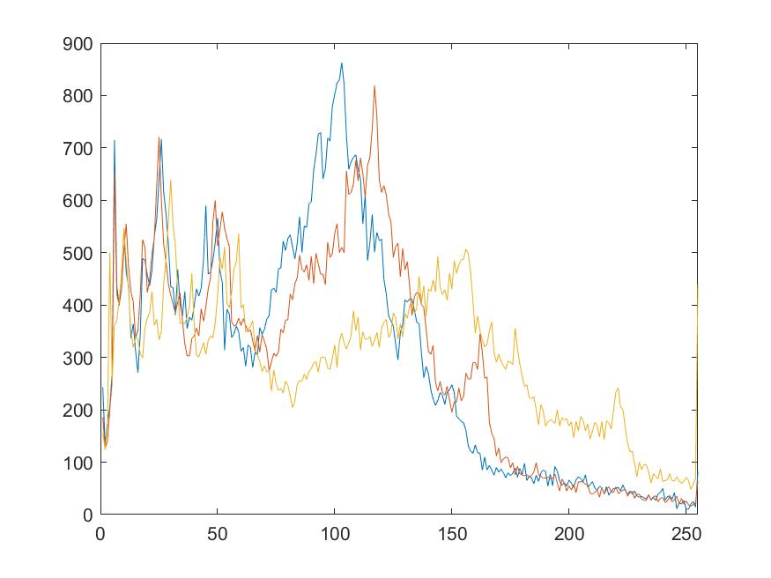

Histogram 1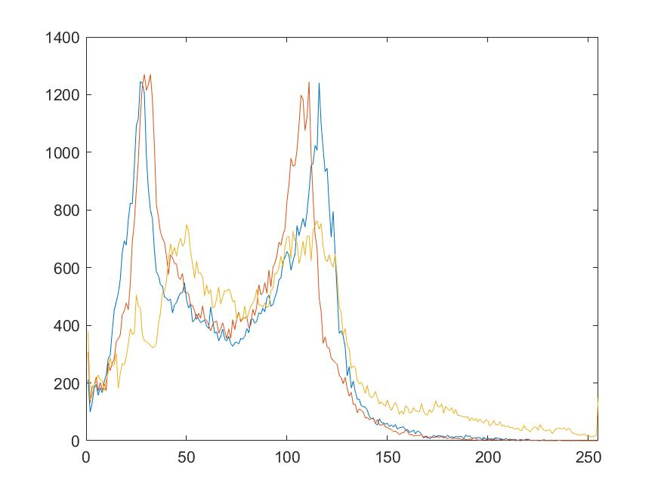

**Your comments:**

**Question 3(b):**

**Example 1:**

It

It+1

**Histograms:**

Histogram of It

Histogram of It+1

Intersection result

**Example 2:**

It+1

It

**Histograms:**

Histogram of It

Histogram of It+1

Intersection result

**Your Comments:**

**Question 3(c):**

**Comments:**